Supplementary Materials
Title: Habitat coupling by small fish across lake-creek habitats: a missing link in freshwater food webs?
Authors: Charlotte A. Ward^{1,2}*, Reilly F. O’Connor¹, Timothy J. Fernandes^{1,2}, Kevin S. McCann^{1,2}, Mark S. Ridgway³, Bailey C. McMeans⁴, Tyler D. Tunney^{5,1}

Extended Methods

Fish community
Lake Opeongo supports a diverse fish community, including native species such as lake trout (Salvelinus namaycush), brook trout (Salvelinus fontinalis), lake whitefish (Coregonus clupeaformis), cisco (Coregonus artedi), white sucker (Catostomus commersonii), yellow perch (Perca flavescens), brown bullhead (Ameiurus nebulosus), burbot (Lota lota), and various leuciscid species, including golden shiner (Notemigonus crysoleucas), common shiner (Luxilus cornutus), creek chub (Semotilus atromaculatus), and bluntnose minnow (Pimephales notatus). The lake also contains introduced smallmouth bass (Micropterus dolomieu), stocked outside their native range during early 20th-century fishery management efforts, where they have since established abundant populations (Jackson 2002). Costello Creek shares many of these species, along with additional members of the Leuciscidae family, such as brassy minnow (Hybognathus hankinsoni), blacknose shiner (Notropis heterolepis), northern pearl dace (Margariscus margarita), finescale dace (Chrosomus neogaeus), fathead minnow (Pimephales promelas), longnose dace (Rhinichthys cataractae), and northern redbelly dace (Chrosomus eos).

Acoustic Telemetry Timeseries
For the fish included in our final acoustic telemetry dataset (n = 44), enriched time series were constructed from the tag-on date (offset by one day to account for variation in release timing) to the tag-off date, which reflected battery life and any “on/off” cycles of transmitters. To generate continuous time series for fish with active tags, we constructed an enriched minute-level time series in which a fish’s last known location (lake or creek) was carried forward if no detection occurred during a given minute, but the fish’s tag was active. This approach is used to reduce gaps in the movement dataset given that fish could easily move out of detection range, especially in the creek and was justified by the close placement of receivers along the lake–creek boundary which ensured that cross-boundary movements would be captured (Larocque et al. 2025). The enriched time series are shown for all transmitters through time in Figure S7.

Trap Net Dimensions
At the mouth of Costello Creek, two small mesh (4mm) fyke nets with an opening size of 39 x 39 inches were deployed. The nets were set with the lead lines blocking the creek, ensuring that fish moving upstream were captured in one net, while fish moving downstream were intercepted and captured by the other. At the upstream culvert location, a custom-made trap net was used, measuring 27 inches in height, 23.5 inches in width, and 36.5 inches in length. The trap was designed with two compartments, one facing upstream and the other facing downstream. To block the entire width of the creek, large block nets (small mesh; 4 mm) were placed on each side of the trap. Fish were inferred to be moving upstream if they were captured in the upstream-facing compartment, while those captured in the downstream-facing compartment were inferred to be moving downstream in the creek.
Standardized surveys were also conducted using minnow traps with dimensions of 10.5" height x 17.5" width x 17.5" length, with three funnels narrowing to 1.5" apertures (22-gauge metal mesh wire). We deployed minnow traps at 10 sites in the creek and 10 sites in the lake, with deployment locations selected to provide broad spatial coverage across Sproule Bay and throughout Costello Creek (Figure S1). Minnow traps were baited with 50 g of dog kibble and set overnight for approximately 12 hours. Upon retrieval the following morning, all captured fish were identified to species and measured for weight, total length, and fork length.

GLM and GAMM Model Structure
Generalized linear models
For liver isotopic composition (δ¹³C, δ¹⁵N) and trophic position in baselines and shiners, we fit GLMs with gaussian distributions. For proportion of lake carbon use, we fit a GLM with a beta distribution using the glmmTMB package in R, to accommodate the proportional nature of the data bound between 0 and 1 (Brooks et al. 2023).
Seasonal variation in habitat recurrence and residency was also analyzed with GLMs using the glmmTMB package in R. Recurrence was modeled with a negative binomial distribution as it was count data with many zeros, whereas habitat residency, another proportional metric bounded between 0 and 1, was modeled with a beta distribution. However, as habitat residency contained zeros and ones, we also transformed the data following Smith & Verkuilen (2006):
$y^{'}= \frac{y\left(N-1\right)+0.5}{N}$ (3),
where $y$ are the original values for lake residency, $y^{'}$ are the adjusted values for habitat residency, and N is the sample size, which in this case represent the total number of minutes in a given season for which a fish’s tag was active.
For directional trap net surveys, the biomass of shiners captured in upstream- and downstream-facing compartments was summed daily, and individual sampling days served as the unit of replication within each season. For minnow trap surveys, total shiner biomass was summed across all individuals captured at each site per sampling occasion, with individual trap sites serving as the unit of replication. With respect to the minnow trapping, standardized surveys caught no shiners in summer months across all traps deployed in the lake. To allow for appropriate statistical analyses, we set the biomass of one of the summer sites to half the minimum observed biomass, similar to work in coral reefs (Mahaut et al. 2025), assuming that shiners are likely present but in densities that are too low for our sampling to detect. This assumption is corroborated by telemetry showing the presence of individuals in the lake during the summer months. Differences in the average daily biomass of shiners captured in upstream vs. downstream trap nets and seasonal shiner biomass captured using minnow trap surveys in the lake and creek were evaluated using GLMs on the log transformed daily flux (gaussian family) and the zero-inflated biomass trapping data (tweedie family). Lastly, differences in total length (mm) of shiners and smallmouth bass, the dominant predator in the system, were modelled using GLMs with gaussian and gamma families respectively.
All models were fit with season and capture location as fixed effects, and tested for an interaction between season and capture location using a Type III analysis of deviance test using the Anova() function from the car package (Fox and Weisberg 2019). When no significant interaction was present, the interaction was removed and the model re-tested with a type II analysis of deviance test. Model estimated marginal means were estimated using the emmeans package and pairwise comparisons were tested for significance using a Tukey-adjusted pairwise comparisons between model terms (Lenth et al. 2026). All analyses were done in R Studio (v. 4.4.0.)
Generalized additive models
To model non-linear patterns in habitat use by shiners over time, we used generalized additive mixed models (GAMMs) using the mgcv package in R with a binomial family and logit link (Wood 2025). Models were used to evaluate the probability of a fish being detected in both lake and creek habitats throughout the year (i.e., being detected at receivers in both habitats on the same day). Day of year (Julian date), our key explanatory variable of interest to assess seasonal habitat use, was included as a cubic spline smooth (k = 10) to capture the cyclic nature of seasonality. To address temporal autocorrelation inherent in repeated detections, we tested the inclusion of a first-order autoregressive correlation structure (corAR1), with autocorrelation estimated separately for each individual fish. We also tested for the inclusion of a random effect for transmitter ID (individual fish). Lastly, we evaluated the inclusion of total length (mm) and release location as fixed effects to account for the potential influence of different release sites. Comparisons of candidate models were based on Akaike Information Criterion (AIC) with the model yielding the lowest AIC considered the most parsimonious. Our top three candidate models suggested that the incorporation of total length and release location were non-significant and did not improve the model considerably (AIC ~ 2.0; Table S5). As such, we went with the simplest model with the lowest AIC, which included a cyclic smooth for day of year, an AR1 correlation structure, and a random effect of transmitter ID.

Tables
Table S1. Examples of the use of lakes and adjacent creeks or streams by freshwater fishes.
Author & Year | Species | Trophic Level / Age Class | Direction of Movement | Hypothesized Driver
Brönmark et al. 2008 | Roach (Rutilus rutilus) | Primary consumer; Adult | Directional (lake→stream for overwintering, return to lake in spring) | Predator avoidance (reducing growth:predation trade-off in lake in winter)
Swanson et al. 2021 | White sucker (Catostomus commersonii); longnose sucker (Catostomus catostomus) | Secondary consumer; Adult | Directional (lake→stream for spawning, return to lake) | Reproduction (spawning); cued by water temperature, discharge, and time of day
Magnuson et al. 1985 | Multiple cyprinids and percids (8 species) | Primary–secondary consumer; YOY (and adult, treated separately) | Directional (lake→stream in fall/winter; stream→lake in spring) for YOY; within-lake vertical movements for adults | Hypoxia avoidance (winterkill avoidance); cued by ice formation or darkness (not oxygen stress itself)
Hahlbeck et al. 2022 | Redband rainbow trout (Oncorhynchus mykiss newberrii) | Tertiary consumer; Adult | Bidirectional (biannual: tributary↔lake) | Thermal refuge (summer) + foraging (spring/fall) + reproduction (winter spawning)
Colborne et al. 2019 | Lake sturgeon (Acipenser fulvescens) | Secondary consumer; Adult | Bidirectional (river↔lake; 5 distinct individual patterns) | Multiple: reproduction (spawning), foraging, and overwintering refuge; high individual variation
Jones et al. 2016 | Longnose sucker (Catostomus catostomus); white sucker (Catostomus commersonii) | Secondary consumer; Adult | Directional (lake→stream for spawning, return to lake) | Reproduction (spawning); nutrient subsidy transfer from lake to oligotrophic stream
He & Kitchell 1990 | Multiple small-bodied cyprinids (6+ species); northern pike (Esox lucius) as experimental predator | Primary consumer; Mixed (adults and juveniles) | Directional (lake→stream ; predation-driven emigration) | Predation avoidance (experimental); also hypoxia avoidance (seasonal)
Curry et al. 1997 | Brook trout (Salvelinus fontinalis) | Secondary consumer; Juvenile (YOY / age-0) | Directional (lake→stream during warmer periods, return to lake in cooler periods) | Thermal refuge (lake littoral temperatures approach lethal levels for YOY in summer; streams cold via groundwater)
Campbell et al. 2019 | Lahontan cutthroat trout (Oncorhynchus clarkii henshawi) | Tertiary consumer; age-0 and age-1+ juveniles | Directional (stream→lake for juveniles during spawning period of adults) | Seeking refuge from spawning adults and foraging opportunities in alternate lake habitat
Dolinsek et al. 2014 | 37 species (diverse community; Lake Ontario tributaries) | Primary–tertiary consumer; All age classes (adults and juveniles) | Bidirectional (lake↔stream) | Multiple: reproduction, foraging, predation refuge; not exclusively spawning — includes partial migration and non-reproductive habitat use
Bentley et al. 2015 | Arctic grayling (Thymallus arcticus); rainbow trout (Oncorhynchus mykiss) | Secondary consumer; Sub-adult | Bidirectional (inter-tributary movements using lake as corridor) | Foraging (prospecting for productive feeding patches; positioning for salmon subsidy)
Kikko et al. 2024 | Honmoroko (Gnathopogon caerulescens) | Primary consumer (planktivore); All age classes (juvenile through adult) | Directional (main lake → lagoons for spawning, with tributaries as corridors) | Reproduction (natal homing to spawning lagoon); foraging (availability of zooplankton prey)
Lindsey & Northcote 1963 | Redside shiner (Richardsonius balteatus) | Primary–secondary consumer; Adult and larvae/fry (treated separately) | Directional (lake→stream for spawning; fry passively downstream stream→lake) | Reproduction (spawning; triggered by temperature >10°C); passive fry displacement away from ephemeral stream habitat

Table S2. Mean (± SD) stable isotope values of δ¹³C and δ¹⁵N (‰) for all organisms sampled in creek and lake habitats across three seasons (Spring, Summer, Fall).
Organism | Location | Month | n | Mean_d13C | SD_d13C | Mean_d15N | SD_d15N
Mayfly | Creek | Spring | 10 | -32.48 | 2.21 | 2.81 | 1.04
 |  | Summer | 10 | -33.55 | 1.66 | 2.4 | 0.42
 |  | Fall | 5 | -31.79 | 0.17 | 3.51 | 0.11
 | Lake | Spring | 23 | -26.38 | 2.49 | 1.85 | 0.81
 |  | Summer | 27 | -24.32 | 2.73 | 0.82 | 0.58
 |  | Fall | 4 | -26.16 | 0.72 | 1.22 | 0.2
Mussel | Creek | Spring | 10 | -30.68 | 0.54 | 4.07 | 0.26
 |  | Summer | 8 | -30.62 | 1.04 | 4.15 | 1.07
 |  | Fall | 3 | -30.83 | 0.59 | 4.43 | 0.84
 | Lake | Spring | 17 | -28.84 | 1.93 | 1.37 | 0.89
 |  | Summer | 22 | -27.76 | 1.52 | 0.83 | 0.71
 |  | Fall | 13 | -28.32 | 0.32 | 1.35 | 0.61
Common shiner | Creek | Spring | 37 | -29.14 | 1.6 | 5.3 | 0.62
 |  | Summer | 15 | -30.11 | 1.3 | 5.5 | 0.77
 |  | Fall | 37 | -28.6 | 1.43 | 5.57 | 0.67
 | Lake | Spring | 22 | -28.51 | 2 | 5.39 | 0.57
 |  | Summer | 1 | -23.01 | NA | 3.8 | NA
 |  | Fall | 5 | -25.3 | 0.86 | 5.55 | 0.32
Golden shiner | Creek | Spring | 40 | -29.07 | 1.23 | 5.72 | 0.78
 |  | Summer | 20 | -30.41 | 1.05 | 5.63 | 0.51
 |  | Fall | 28 | -29.86 | 1.38 | 5.62 | 0.74
 | Lake | Spring | 27 | -28.41 | 0.81 | 5.55 | 0.65
 |  | Summer | 2 | -26.5 | 0.87 | 4.85 | 0.14
 |  | Fall | 18 | -26.67 | 2.01 | 5.07 | 0.88

Table S3. Results of generalized linear models (GLMs) testing the effects of season, release location, and their interaction on stable isotope values (δ¹³C and δ¹⁵N) of mayflies and mussel samples. Chi-squared statistics and p-values are from Type II or Type III likelihood ratio tests.
Variable | Factor | Chi Squared | df | p-value | Model type
Mayfly δ¹³C | Season | 0.682444 | 2 | 7.11E-01 | Gaussian GLM - Type III
 | Release location | 109.7741 | 1 | 1.10E-25
 | Season:release location | 7.894751 | 2 | 1.93E-02
Mayfly δ¹⁵N | Season | 18.21115 | 2 | 1.11E-04 | Gaussian GLM - Type III
 | Release location | 67.65177 | 1 | 1.95E-16
 | Season:release location | 7.212057 | 2 | 2.72E-02
Mussel δ¹³C | Season | 24.11066 | 2 | 5.81E-06 | Gaussian GLM - Type II
 | Release location | 42.41295 | 1 | 7.39E-11
Mussel δ¹⁵N | Season | 29.14971 | 2 | 4.68E-07 | Gaussian GLM - Type II
 | Release location | 303.6874 | 1 | 5.18E-68

Table S4. Results of generalized linear models (GLMs) testing the effects of season, location of capture/release, and their interaction on shiner coupling metrics (foraging, movement, and biomass) and the size of shiners and smallmouth bass captured within lake and creek habitats. Chi-squared statistics and p-values are from Type II or Type III likelihood ratio tests.
Variable | Factor | Chi Squared | df | p-value | Model type
Prop. lake carbon | Season | 37.80335 | 2 | 6.18E-09 | Binomial GLM - Type III
 | Location | 64.76723 | 1 | 8.43E-16
 | Season:location | 49.03206 | 2 | 2.25E-11
Trophic position | Season | 13.80686 | 2 | 1.00E-03 | Gaussian GLM -Type III
 | Location | 40.58478 | 1 | 1.88E-10
 | Season:location | 25.36142 | 2 | 3.11E-06
Recurrence | Season | 32.67014 | 2 | 8.05E-08 | Negative binomial GLM - Type II
 | Release_location | 11.01503 | 1 | 9.04E-04
Residency | Season | 4.085497 | 2 | 0.129672 | Binomial GLM - Type II
 | Release_location | 9.227021 | 1 | 0.002385
Directional trap biomass | Season | 29.97675 | 2 | 3.09E-07 | Gaussian GLM -  type III
 | Direction | 0.536987 | 1 | 4.64E-01
 | Season:direction | 16.3676 | 2 | 2.79E-04
Minnow trap biomass | Season | 9.234694 | 2 | 9.88E-03 | Tweedie GLM with log link -type III
 | Location | 9.851438 | 1 | 1.70E-03
 | Season:Location | 9.039771 | 2 | 1.09E-02
Shiner total length | Season | 1.186125 | 2 | 5.53E-01 | Gaussian GLM - type III
 | Location | 153.4348 | 1 | 3.08E-35
 | Season:location | 30.81639 | 2 | 2.03E-07
SMB total length | Season | 5.629744 | 2 | 5.23E-02 | Tweedie GLM with log link - type III
 | Location | 124.9957 | 1 | 4.43E-25

Table S5. Model selection results for candidate generalized additive mixed models evaluating drivers of movement among habitats. Candidate models included combinations of a cyclic smooth for day of year (s(day_of_year)), body size (tl, modeled as either a linear or smooth term), and release location. Model support was assessed using Akaike’s Information Criterion (AIC), with lower AIC values indicating better fit relative to model complexity. ΔAIC gives the difference from the top-ranked model, and model weights indicate relative support among the candidate set. The selected model is bolded.
Model | Formula | K | logLik | AIC | ΔAIC | Weight
gamm_3 | s(day_of_year) + s(tl) + release_location | 7 | -4217.75 | 8449.508 | 8487.431 | 1665
gamm_1 | s(day_of_year, bs = "cc") + s(tl) + release_location | 6 | -4246.72 | 8505.439 | 8537.944 | 1665
gamm_0 | s(day_of_year, bs = "cc") + s(tl) + release_location | 5 | -4366.85 | 8743.702 | 8770.79 | 1665
gamm_2 | s(day_of_year, bs = "cc") + s(tl) + release_location | 6 | -4417.36 | 8846.723 | 8879.228 | 1665
gamm_3c | s(day_of_year, bs = "cc") + release_location | 5 | -4217.55 | 8445.103 | 0 | 0.564
gamm_3d | s(day_of_year, bs = "cc") | 4 | -4219.57 | 8447.134 | 2.032 | 0.204
gamm_3b | s(day_of_year, bs = "cc") + tl + release_location | 6 | -4217.75 | 8447.504 | 2.402 | 0.17
gamm_3a | s(day_of_year, bs = "cc") + s(tl) + release_location | 7 | -4217.75 | 8449.508 | 4.406 | 0.062

Figures
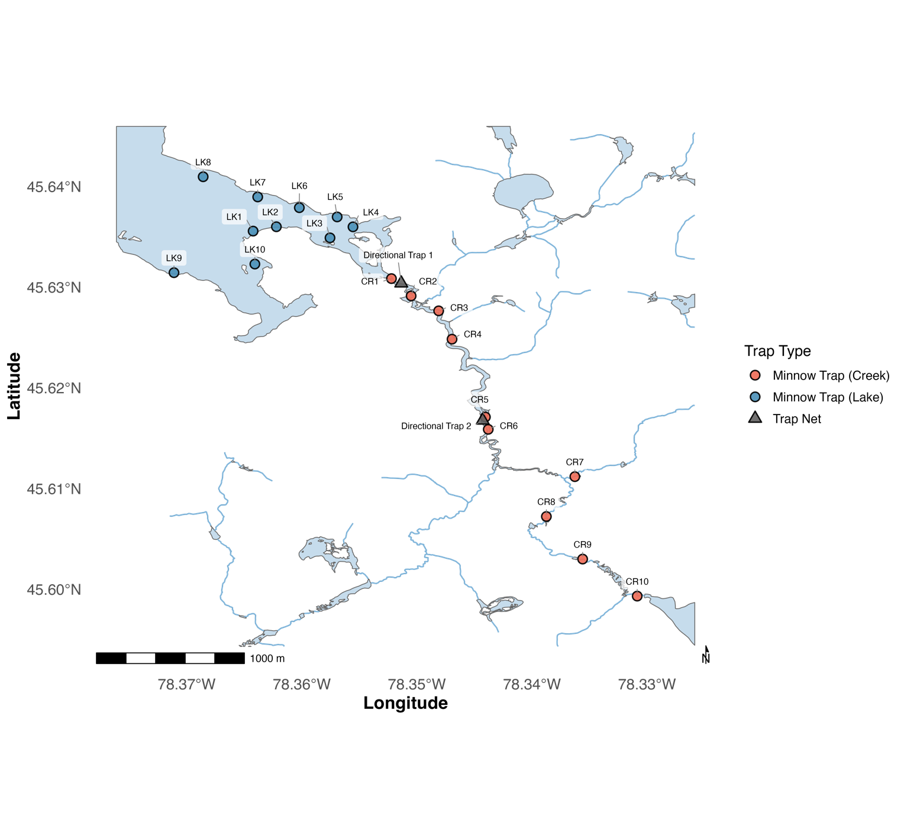
Figure S1. Locations of minnow traps (pink and blue circles) and directional trap nets (grey triangles) within the study system. Ten minnow traps were deployed throughout each habitat (lake and creek) during each sampling season. Directional trap nets were positioned at the mouth of Costello Creek (Directional Trap 1) and approximately two kilometers upstream (Directional Trap 2) to capture fish moving directionally between habitats.

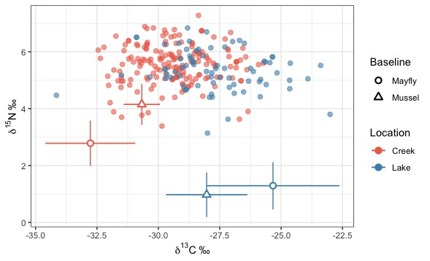
Figure S2. Biplot of δ¹³C and δ¹⁵N stable isotope values from shiner liver tissue (n = 252). Each point represents an individual shiner liver sample, coloured by the location in which the fish was captured (lake = blue, creek = pink). Baseline values are shown as mean ± SD for mayflies and mussels collected in each habitat across the study period.

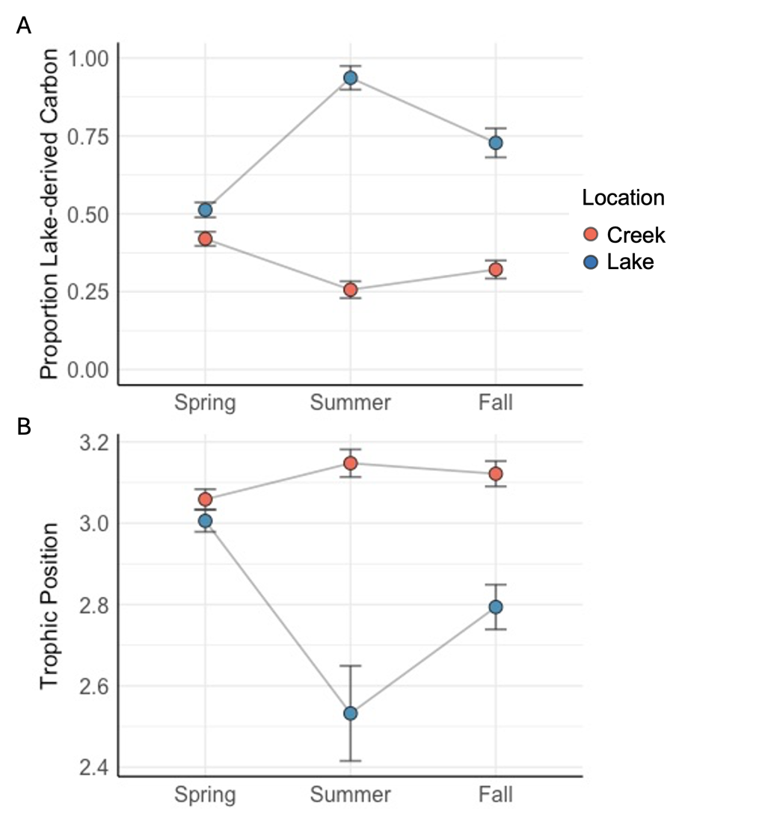

Figure S3. Mean (±SE) proportion of lake-derived carbon (A) and trophic position (B) of fish captured in the creek (pink) and lake (blue) across seasons calculated from non-lipid corrected stable isotope data.
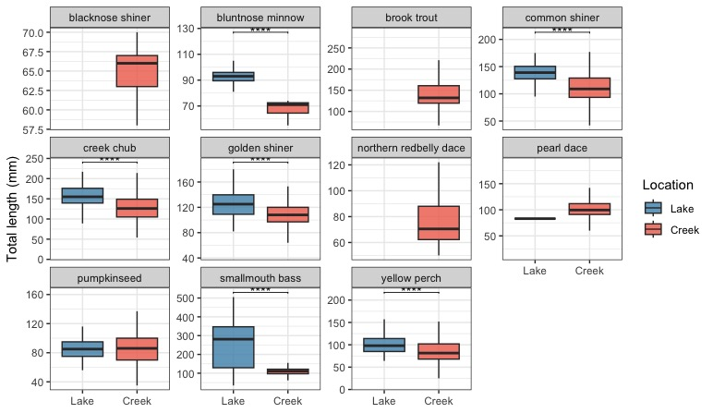

Figure S4. Boxplots of total length (mm) for fish species captured in lake (blue) and creek (pink) habitats across the study period. Each panel shows a different species. Asterisks denote significant differences in total length between habitats based on species-specific habitat comparisons, using Welch t-tests or Wilcoxon rank-sum tests as appropriate (*p < 0.05, **p < 0.01, ***p < 0.001, ****p < 0.0001).

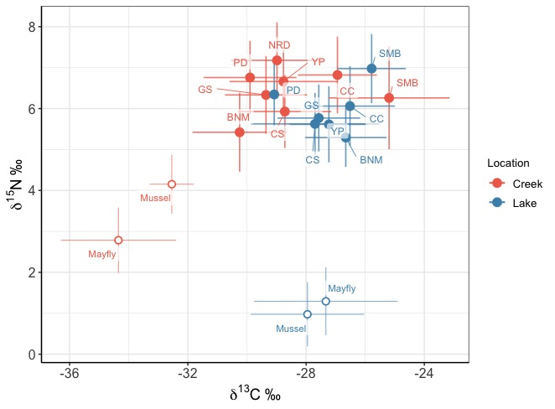

Figure S5. Biplot of mean (± SD) δ¹³C and δ¹⁵N stable isotope values from liver tissues of fish species captured in lake (orange) and creek (blue) habitats. Points represent species means, labelled with species abbreviations (BNM = bluntnose minnow, CC = creek chub, CS = common shiner, GS = golden shiner, NRD = northern redbelly dace, PD = pearl dace, SMB = smallmouth bass, YP = yellow perch). Baseline values are shown for mayflies and mussels collected in each habitat.

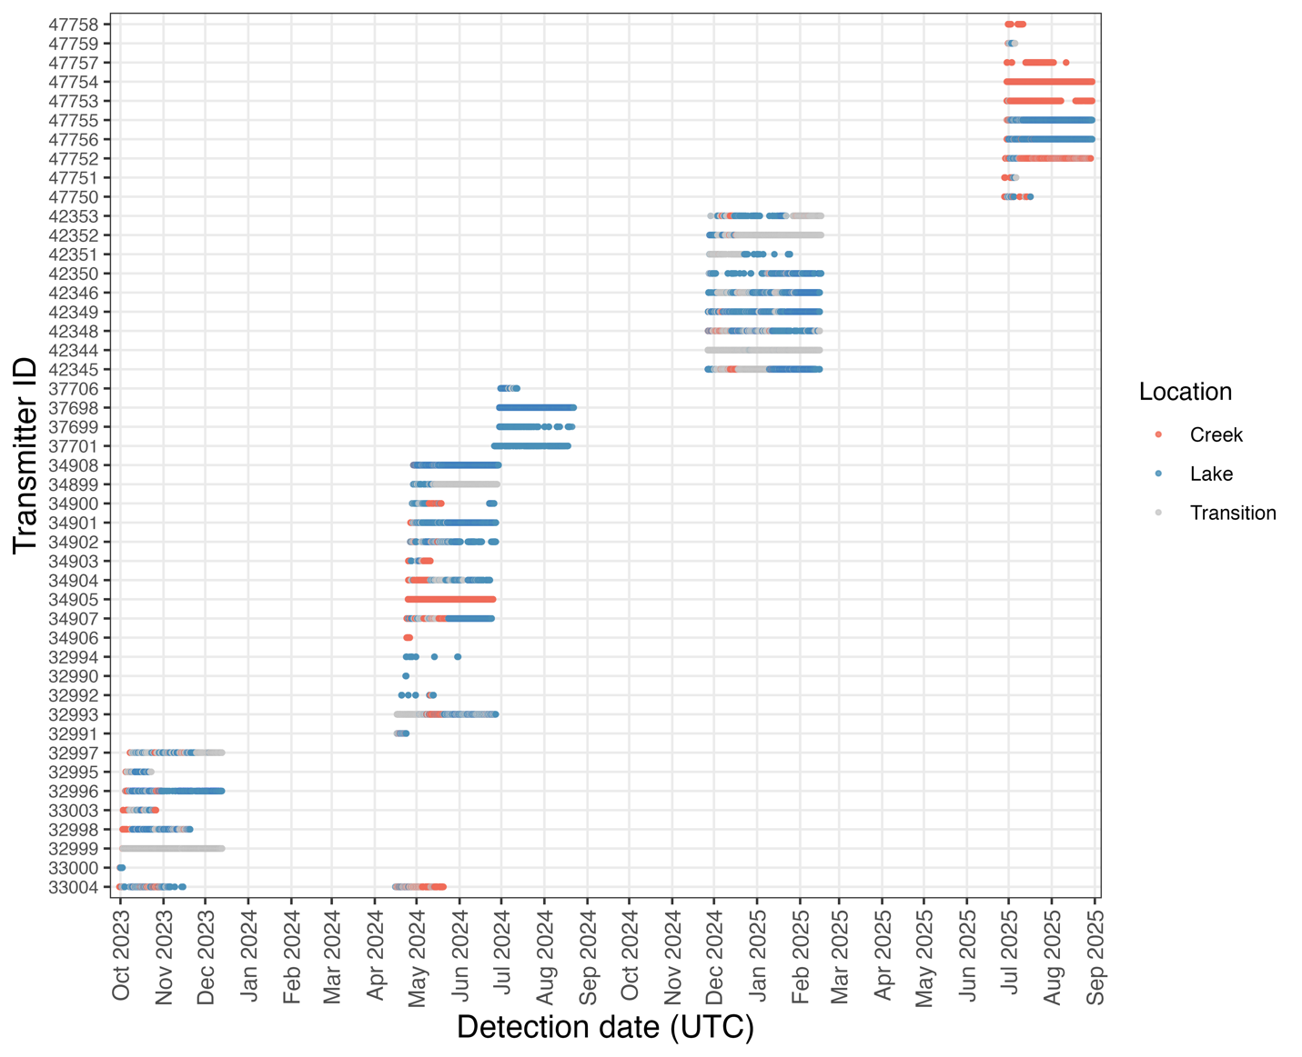
Figure S6. Abacus plot of acoustic telemetry detections for tagged golden shiners from October 2023 to September 2025. Each row represents an individual fish (identified by transmitter ID), with points showing detections over time. Colours indicate the location (habitat) the fish was in at the time of detection (creek = pink, lake = blue, transition = grey).
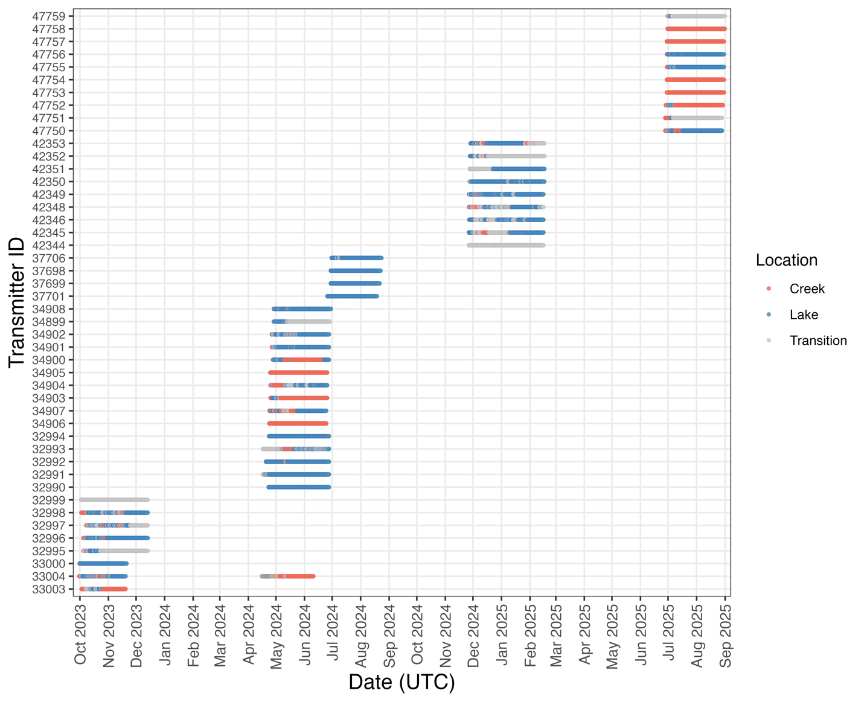
Figure S7. Abacus plot of enriched acoustic telemetry dataset for tagged shiners from October 2023 to September 2025. Each row represents an individual fish (identified by transmitter ID), with horizontal bars showing continuous periods where the last known location was carried forward in the absence of detections within a given minute. Colours indicate the location (habitat) the fish was in at the time of detection (creek = pink, lake = blue, transition = grey).

